Tumble Skull

Alone, decrepit, with no direction, the wild west won’t wait round for you to pull yourself up by the bootstraps. Git on goin’ and tumble around, cowboy.

By, Katherine Rosell

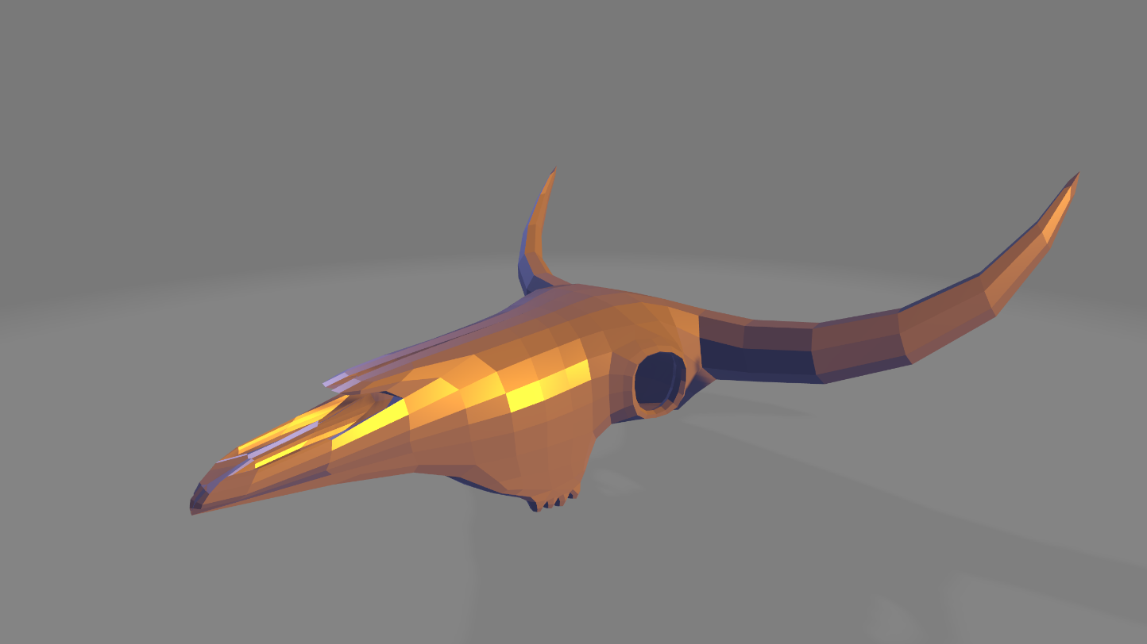

Table of Contents

The Revisited Game

Overview

Audience/Platform

Gameplay and Mechanics

Art Style

Agile Method and Scrum Workflow

Future Development/Post Mortem

The Revisited Game

This game was originally a one-button high score game for windows computers. The gameplay was simple, uncomplicated. You played as a cube on a platform and had to jump as many times as possible to gain points. Every certain amount of time there is a key that is the designated jump key – meaning, one of the 26 letter keys available allows the player to jump and earn points. Pressing any other key that is not the designated jump key, as it reads on screen, results in an automatic game over.

The problem with this mini high-score game is that there was not much to it. While the basic gameplay was not all that difficult it left a lot of room for improvement. I knew I wanted to improve on the gameplay and interactions, especially allow the player to move around the screen and add layers of difficulty. This train of thought made my move to porting this as a 3D mobile game, that way it’s a worthy portfolio piece to show off too.

Overview of Tumble Skull

Tumble Skull allows players to tumble around the map to avoid tumble weeds for as long as they can! The wind blows them in from all four directions so the player has to move around the map, stumbling with the janky controls to avoid the tumbleweeds. The skull of the bull will have multiple colliders so the player can really feel like a tumbling skull in the dessert! The game is made to be a portfolio piece to show my knowledge and understanding of developing for mobile games. The fun of this game is the goofy janky-ness, it is a pretty short game that takes about 4 minutes of gameplay until the player loses.

The ideal version of the game with future development will allow players to share their scores across different social media platforms and have their highest score saved in the game.

Audience

This game is for the casual mobile game player as well as potential employer to check out. Though the age range would most likely be 4+.

Platform

The project is built in Unity (version 2018.2.7.1f) for Android devices. The project was playtested using Unity Remote 5 on an iOS device. Re-importing all assets may result in a loss of the CowSkull.ma and CowSkull.meta files – these Maya files need to be either remade in Blender as OBJECT or FBX files, or converted as such. Unity automatically uses the most up-to-date version, which currently (8/22/2020) is 2019.4.8f. In order to reset the version of the project to its original, go to ‘Help’ 🡪 ‘Reset Packages to Default’.

Gameplay and Mechanics

The player can move around the 3D environment by tilting the screen toward/away from themselves as well as left and right.

Art Style

----

Discuss the art style that the game will focus on. What will the player see when the game starts up? How does the UI look? This section will mostly be filled with wireframes, screenshots of artwork in-game, or assets that will illustrate the overall look of the game.

Agile Method and Scrum Workflow

----

Here is a nitty-gritty part that discusses the backend of how the game will be developed. Will there be a team of people just working on programming one week, then they all work on art the next? It doesn’t have to be very specific, it could even be as general as assigning team members or yourself roles and deadlines for project versions. Project versions meaning there is an MVP, a beta version, working alpha of the sort, and time for playtests in between.

Future Development/Post Mortem

----

This section is optional and should be filled out when the game is either complete or has exhausted the development team to the point where everyone agrees this is the end of development. With more time to work on this game, what would you do differently? How did development go? What worked and did not work? Be honest and brief in this section as it is a reflection and will only be seen by the team.